NAGS HEAD 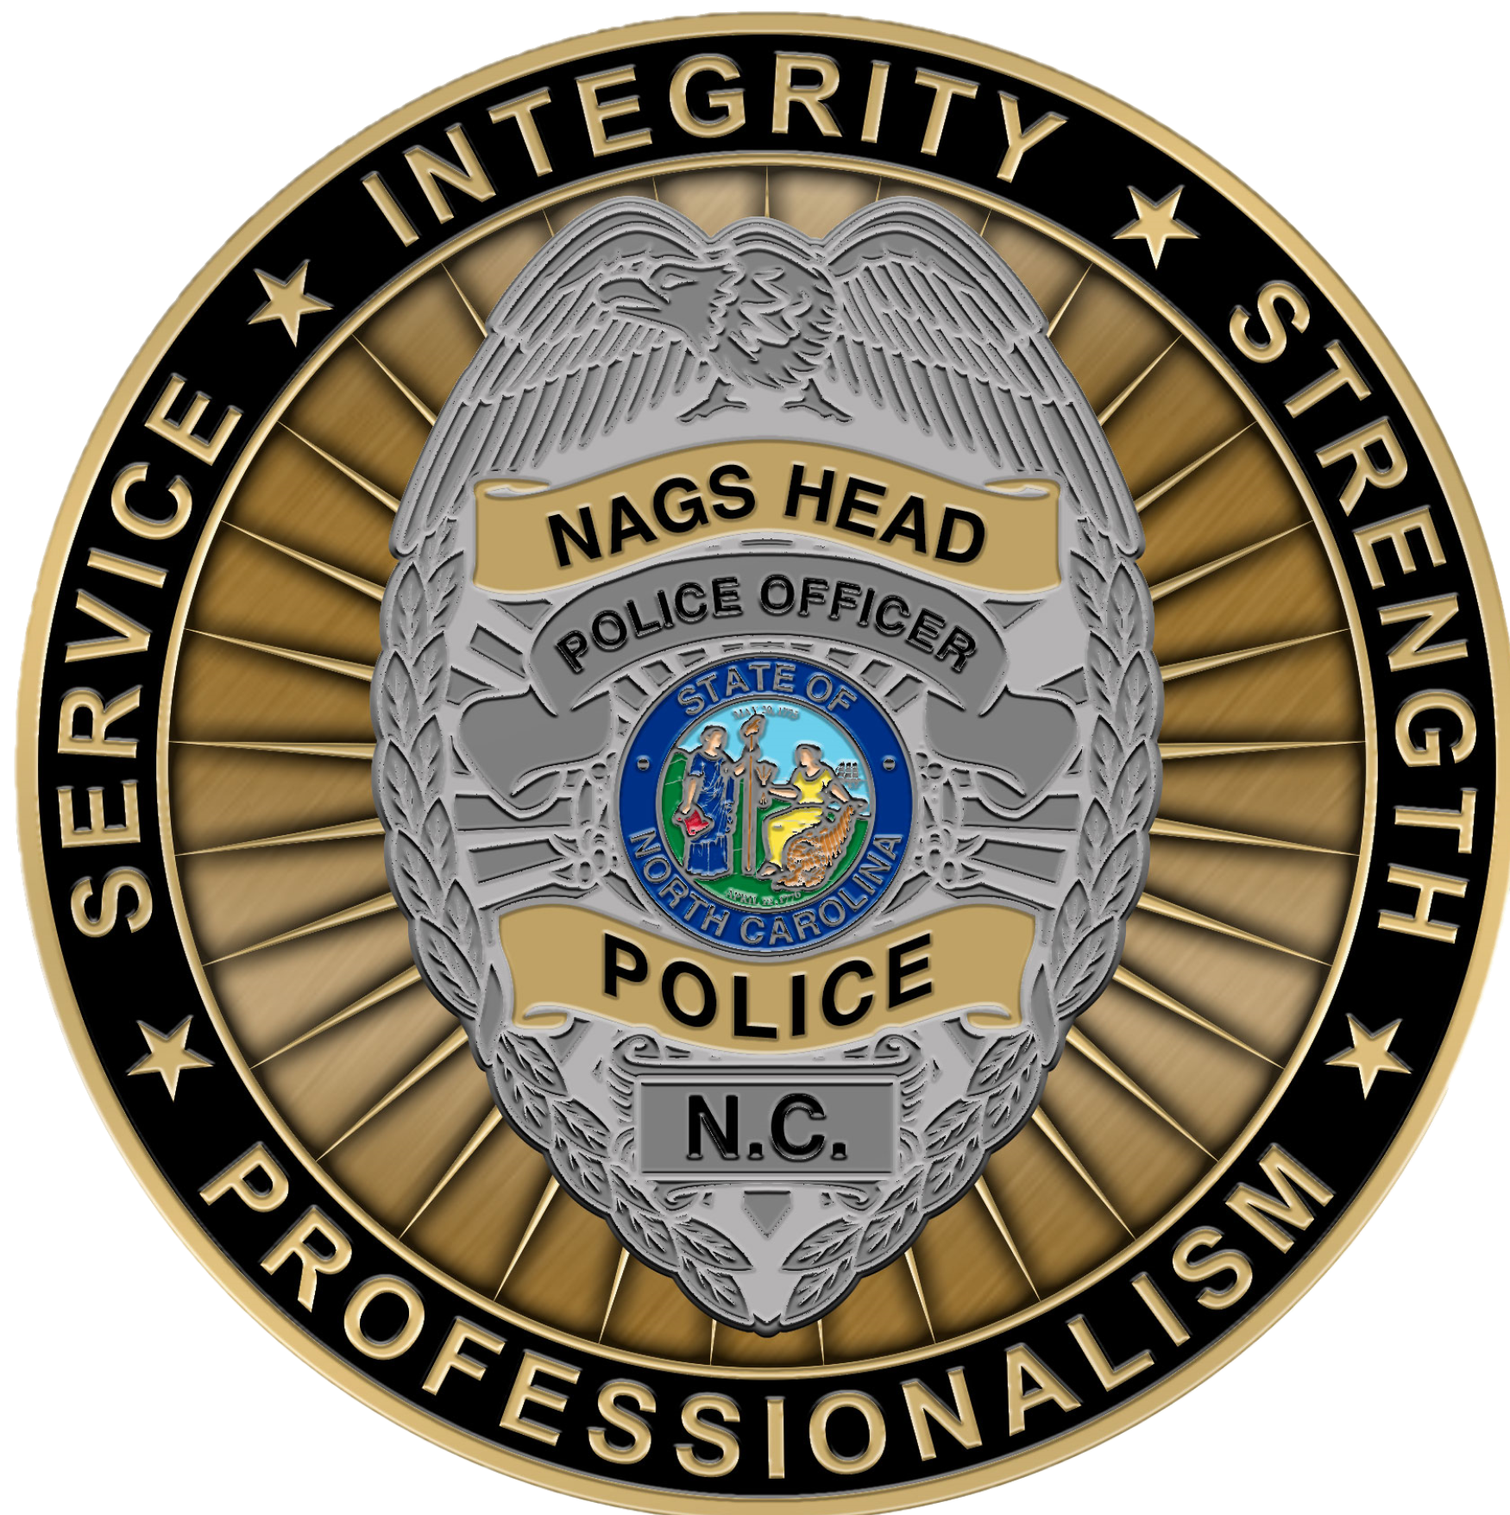

POLICE DEPARTMENT

Department Specific Employee Benefits

 | Probation Increase |  | Upon completion of an employee’s six-month probation period, an automatic increase in salary occurs. |  | 5% increase
 | Career Progression Program |  | Upon completing required time and mandated training courses/hours, an employee can achieve up to four steps of career progression. Those with prior Law Enforcement experience are accelerated in achieving steps, and each step is an increase in salary. |  | 5% increase per step
 | Night Shift Differential |  | Those working between the hours of 6:00 pm and 6:00 am receive a shift differential bonus in pay for those hours worked |  | $1.00 per hour increase
 | Take Home Vehicle |  | Employees are permitted to drive their assigned departmental vehicle to their residence if it is within the allotted distance from the town line. |  | 50 miles road distance
 | Off-Duty Security Opportunities |  | The Town hosts multiple annual events which require additional police staffing. These events are required to hire officers in an off-duty capacity with a four-hour minimum. |  | $50.00 per hour
 | Officer Wellness Leave |  | A benefit which allows officers to accumulate additional days of leave to be used for mental wellness away from the workplace. |  | Tiered amounts based off years of service
Annual Increases |  | With-in-grade and Merit increases occur annually based off time in position and performance. |  | WIG – 1.25% to 2.5%  Merit – Up to 5%

