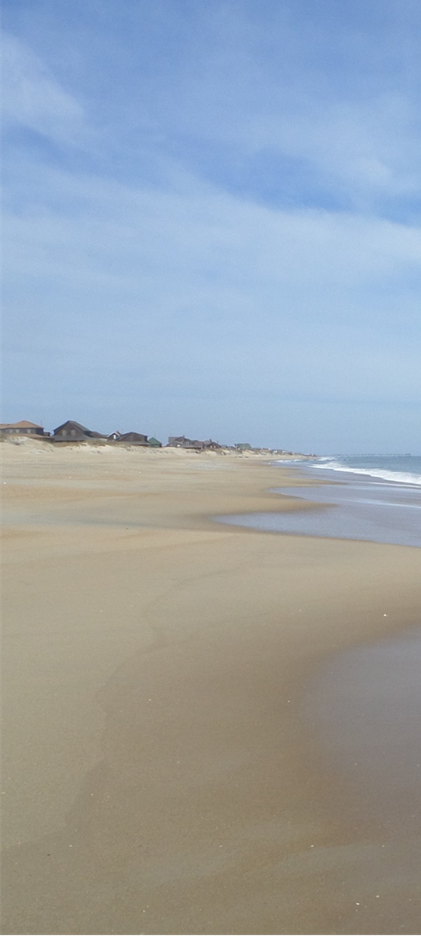



SALARY AND BENEFITS

Starting Salary Range
$53,802 - $69,943

- Competitive Salary and Career Progression with 5% step increases
- Insurance; Health, Dental, Vision
- Vacation & Sick Leave
- Retirement (LGERS, 401K)
- All Equipment and Uniforms Provided
- Advanced Training
- Opportunities for Advancement
- Take-Home Car Program
- Life at the Beach

SALARY AND BENEFITS

- Competitive Salary and Career Progression
- Insurance; Health, Dental, Vision
- Vacation & Sick Leave
- Retirement (LGERS, 401K)
- All Equipment and Uniforms Provided
- Advanced Training
- Opportunities for Advancement
- Take-Home Car Program
- Life at the Beach

APPLICATION PROCESS

To become a Nags Head Police Officer, you must be a U.S. Citizen, at least 20 years of age, be able to obtain a NC Driver’s License, have a High School Diploma or equivalent, and NC BLET certification, or Out-of-State equivalent. Prior experience, and/or post-secondary education, are preferred.


The hiring process includes…

- Initial Application
- Personal History Statement
- Panel Assessment
- Background Investigation
- Physical and Drug Screening

NAGS HEAD POLICE DEPARTMENT
5401 South Croatan Hwy, PO Box 99
Nags Head, NC 27959
Phone: (252) 441-6386

Website: http://www.nagsheadnc.gov

NAGS HEAD POLICE DEPARTMENT

Outer Banks

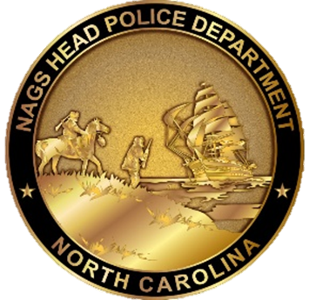

The

Serve On

Our Mission

We are the guardians of life and property in our coastal community. We will deter crime and disorder and be resilient in times of peril.

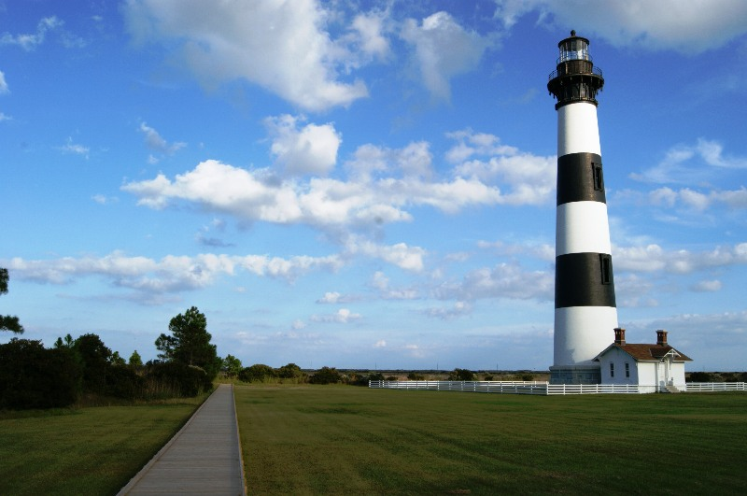

History and Sites

Nags Head and the Outer Banks area have a storied history from the days of the first English settlers, to piracy, and the first powered flight.

Located within Nags Head is Jockey’s Ridge State Park. The park is the site of the tallest living sand dune on the east coast and a mecca for kite flying and hang-gliding enthusiast.

Also, in Town is Nags Head Woods, a thriving maritime forest ecosystem. The forest is located on the northern end of Town and borders the Roanoke Sound.

Nags Head is home to world class watersports locations including: surfing, paddle boarding, kite surfing and fishing.

Nags Head is located between three national parks: Fort Raleigh in Manteo, Wright Brothers Memorial in Kill Devil Hills and the Cape Hatteras National Seashore.

A

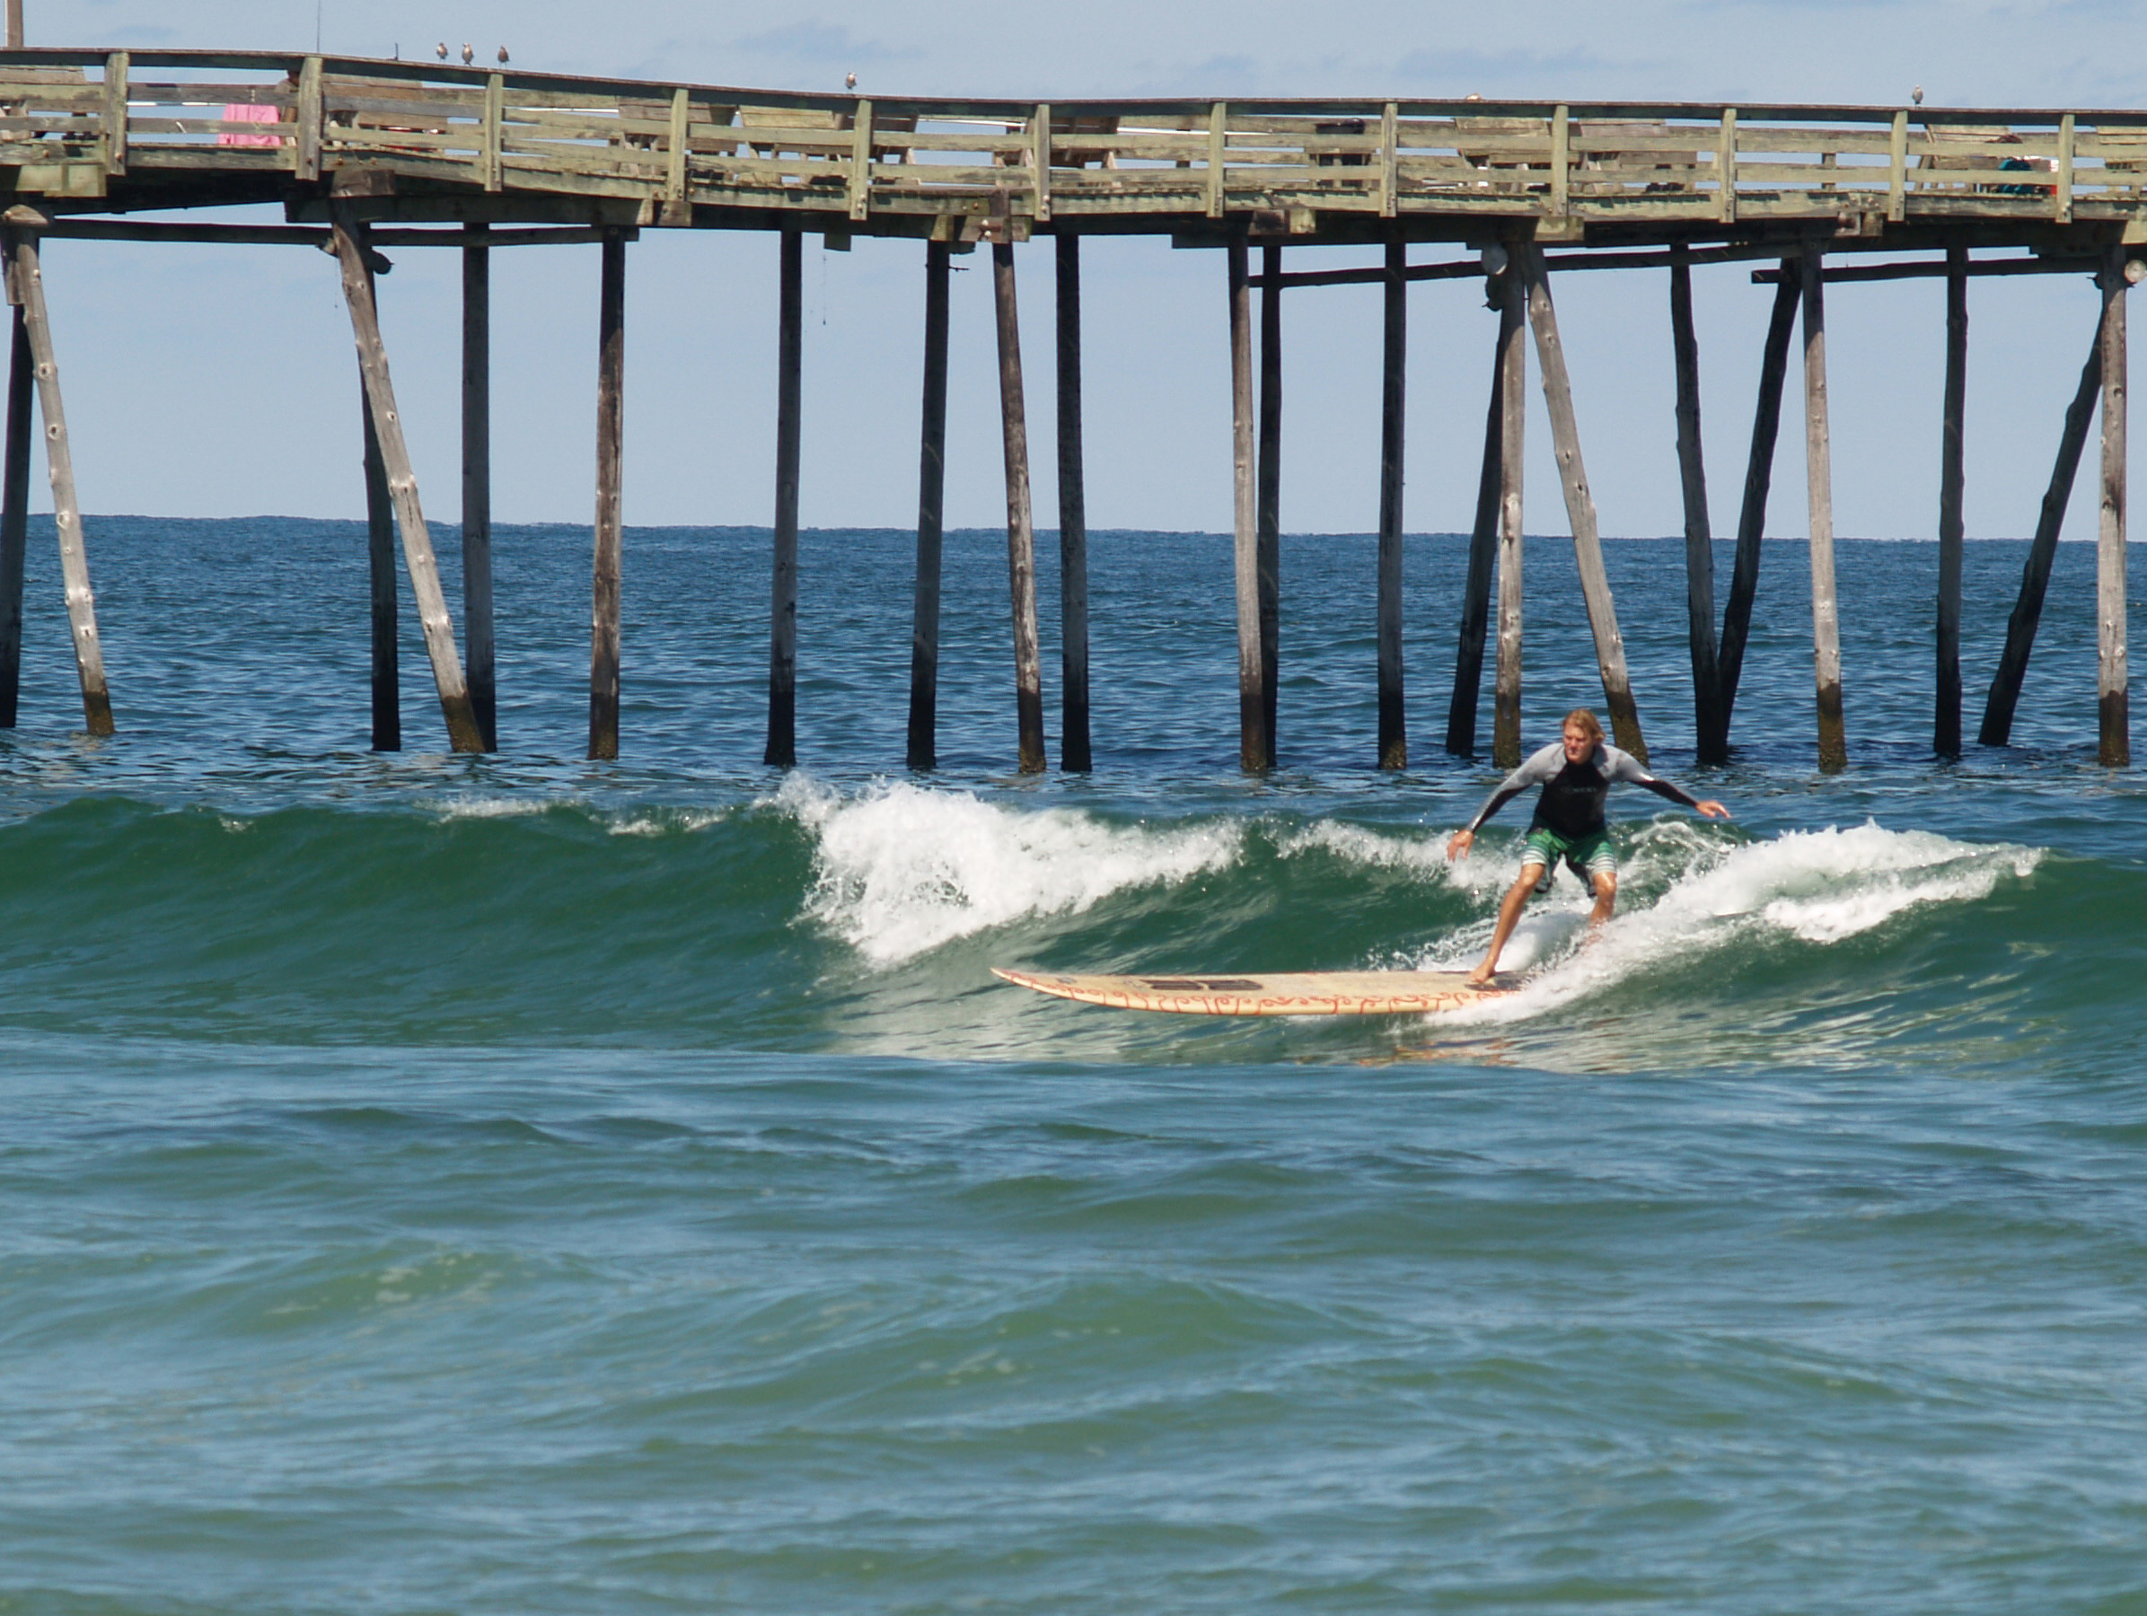

Why the Town of Nags Head?

The Town of Nags Head is a vibrant oceanfront resort town located on the Outer Banks of North Carolina. The town was incorporated in 1961. The town adheres to the Council-Manager form of government and has an annual budget of $17 million dollars.

The Town is proud of its ocean centric and active style of living. From surfing to fishing there is something for everyone to enjoy.

The area offers excellent educational opportunities which include; K-12 public school district, and nearby College of the Albemarle’s Campus’ in Manteo and Elizabeth City, NC.

The town has a permanent population of close to 2,900. Our population grows to over 40,000 people daily during the main tourism months.

THE POLICE DEPARTMENT

We are a full-service law enforcement agency that was created along with the Town of Nags Head in 1961. The department has a budget of $2.8 million dollars.

The department is comprised of 27 officers and staff who serve in patrol, criminal investigations, and administration.

Specialty positions include:

- School Resource Officer
- Emergency Response Team
- Beach Patrol
- Criminal Investigations Division
- K9 Officers

Our Officers use concepts of Community Oriented Policing and Problem Solving in order to carry out service to our community. We partner with our community and invest in relationships.
